Orbital Shaker-Incubator—TOS30
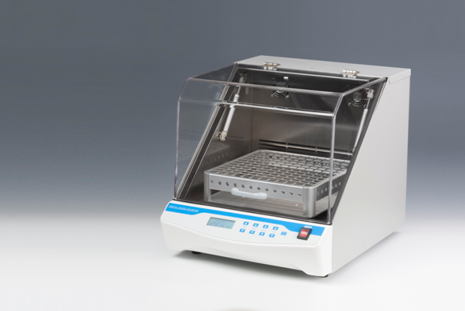
Description:
Orbital Shaker-Incubator, combining shaker and incubator, is a compact bench–top shaking incubator used for mixing of biological liquids as well as for incubation and cultivation of biological liquids. Interchangeable platforms allow it mix and culture samples in flask, petri dish, tubes and etc. Built–in microprocessor thermo controller provides constant temperature control in the incubator chamber. It is extremely easy to operate, with very straightforward setup of temperature, speed and time.

Features:
- Instantly display operation information(time, temperature and speed) on
the LCD screen.
- Gentle and reliable shaking with direct brushless DC motor.
- The incubator features acrylic lid to allow easy visibility of and access to
the samples.
- Constant temperature control ensures even temperature distribution in
the chamber.
- Running safely –-heating and shaking will be automatically stopped once
the lid is open.
- Auto restart in case of power failure.
- Over-heating protection device is included.
- Built-in temperature calibration function.

Parameters:
Type  Parameter | TOS30
Temperature setting range | 0°C ~60°C
Temperature control range | RT.+5°C ~60°C
Time range | 1min ~ 99h59min/∞
Temp. accuracy | ≤±0.5°C(@37°C)
Display accuracy | 0.1°C
Temp. uniformity | ≤±0.5°C(@37°C)
Shaking range | 50~250rpm
Heating time | ≤20min(from 25°C to 60°C)
Orbit | 20mm
Platform dimension | 350x350mm
Internal chamber height | 325mm
Load capacity | 10.0kg
Auto resume to run | Yes
Power | 600W
Voltage | AC220V or AC110V/50-60HZ
Fuse | 250V 3A Ф5×20
Dimension(mm) | 632x502x512
Weight(kg) | 41

Optional Platforms
Type | Description
TOS30-T1 | Platform with clamps for 9×250ml conical flask
TOS30-T2 | Platform with clamps for 25×100ml conical flask
TOS30-T3 | Flat platform for 16pcs petri dishes
TOS30-T4 | Platform with spring holder

